**PLANNING PROPOSAL**

To rezone part Lot 341 in Deposited Plan 1262760 from SP2 – Water Reservoir to R2 – Low Density Residential pursuant to State Environmental Planning Policy (SEPP) (Precincts – Central River City) 2021

**June 2023**

**Contents**

EXECUTIVE SUMMARY 1

PART 1 – OBJECTIVES AND INTENDED OUTCOMES 5

PART 2 – EXPLANATION OF PROVISIONS 6

PART 3 – JUSTIFICATION OF STRATEGIC AND SITE-SPECIFIC MERIT 7

A. NEED FOR THE PLANNING PROPOSAL 8

B. RELATIONSHIP TO STRATEGIC PLANNING FRAMEWORK 8

C. ENVIRONMENTAL, SOCIAL AND ECONOMIC IMPACT 13

D. INFRASTRUCTURE (LOCAL, STATE AND COMMONWEALTH) 13

E. STATE AND COMMONWEALTH INTERESTS 13

PART 4 – MAPPING 14

PART 5 – COMMUNITY CONSULTATION 15

PART 6 – PROJECT TIMELINE 16

APPENDIX A – Letter of Approval – *Sydney Water Corporation*

EXECUTIVE SUMMARY

**Brief overview and background to the Planning Proposal**

The subject site is located on the north-eastern side of Cudgegong Road, between Guntawong Road to the north-west and Rouse Road to the south-east. The site encompasses an area of approximately 1.29 hectares, and is rectangular in shape with a frontage of 72.05 metres to Cudgegong Road. The site is currently occupied by a single storey dwelling.

The majority of the site is zoned R2 – Low Density Residential pursuant to State Environmental Planning Policy (SEPP) (Precincts – Central River City) 2021. A 14.13 metre strip of land extending along the north-western boundary of the site is zoned SP2 – Water Reservoir.

On 24 October 2019, Council granted Development Consent (DA-2018-01684) for *“Demolition of the existing dwelling, tree removal, staged construction of a 2 storey Place of Public Worship, for 400 parishioners. Car parking for 100 vehicles provided at ground and in a basement car park, site preparation works and landscaping”*.

The approved development occupies the portion of the site zoned R2 – Low Density Residential, and the development does not extend onto the portion of the site zoned SP2 – Water Reservoir.

Irrespective, the portion of the site zoned SP2 – Water Reservoir forms part of the allotment the subject to the Development Consent, circumstances in which Conditions 2.1.3 and 5.5.1 were imposed to remove the redundant zoning of the land in circumstances where the land is not required by *Sydney Water* for the purpose for which it is currently zoned.

That is, in circumstances where the land is not required by the *Sydney Water Corporation*, the current zoning of the land is unnecessary and inappropriate, and Conditions 2.1.3 and 5.5.1 were imposed to resolve that anomaly as follows:

*Condition 2.1.3*

*The applicant shall liaise with Sydney Water regarding the purchase of the SP2 zoned land prior to works commencing on site. Written evidence shall be submitted to Council of Sydney Water’s advice to either purchase the land or not. In the event that Sydney Water does not seek to purchase the land, a planning proposal to rezone the land shall be lodged with Council prior to the release of the Construction Certificate.*

*Condition 5.5.1*

*Prior to the release of the Construction Certificate, written confirmation is to be submitted to Council that a Planning Proposal has been submitted to rezone the SP2 zoned land, in the event that Sydney Water do not seek to purchase the land.*

On 28 February 2019, the *Sydney Water* Corporation advised the owner that the strip of land zoned SP2 – Water Reservoir was not required for any purpose. Further, the *Sydney Water Corporation* advised the owner that it supported the proposed rezoning, and requested a 2 metre wide easement over the land which is now registered on the title.

In the circumstances, the purpose of the Planning Proposal is to satisfy Conditions 2.1.3 and 5.5.1 of the Development Consent and rezone the subject land from SP2 – Water Reservoir to R2 – Low Density Residential pursuant to SEPP (Precincts – Central River City) 2021.

Finally, it is proposed to amend the Lot Size Map (to specify a minimum lot size of 2,000m2) and the Height of Buildings Map (to specify a maximum building height of 8.5 metres) to provide consistency with the controls applying to the remainder of the site.

**Land to which this Planning Proposal applies**

The subject site formally comprises part Lot 341 in Deposited Plan 1262760. The portion of the site zoned SP2 – Water Reservoir extends along the north-western boundary, and has a width of 14.13 metres, and a length of 178.77 metres.

The site was formed by the consolidation of Lot 3 (and part Lot 4) in Deposited Plan 564381. The consolidation was made possible when the owner of the land acquired a disused access handle extending along south-western boundary from the *Sydney Water Corporation*.

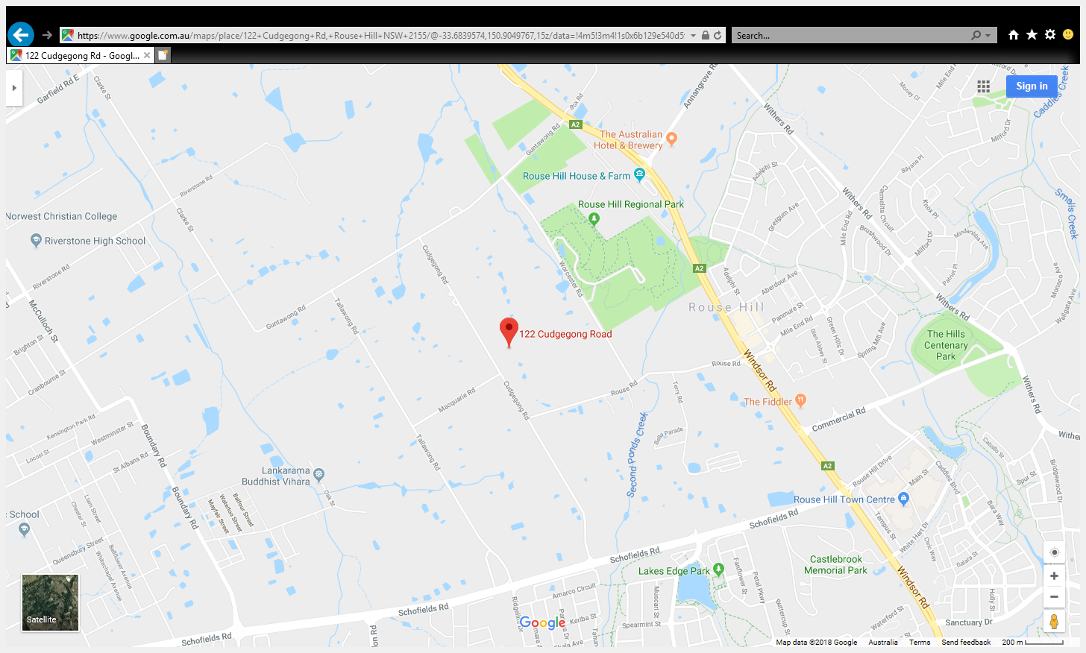

**Figure 1: Location**

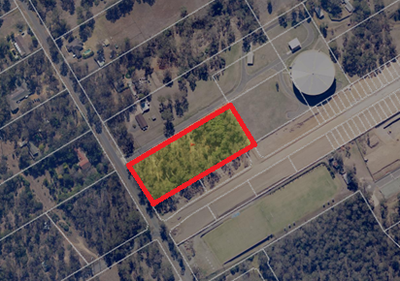

**Figure 2: Site**

**Existing Planning Controls**

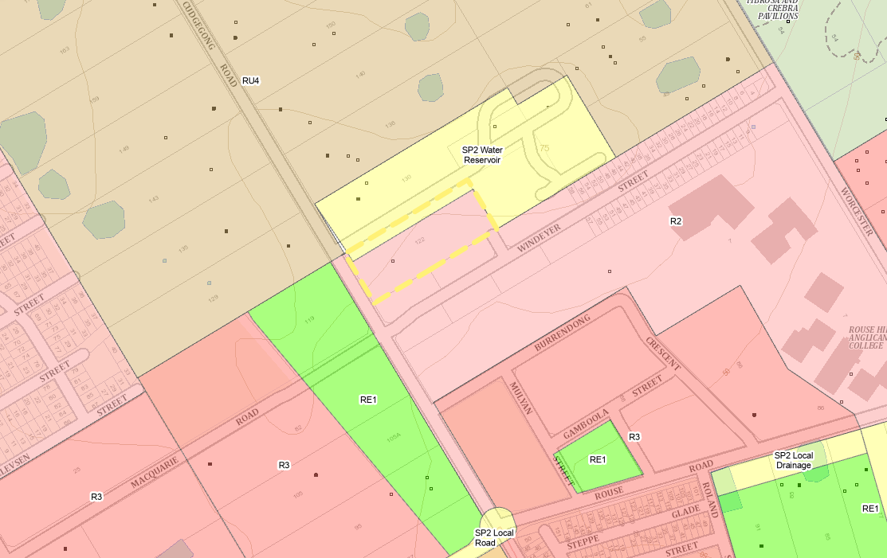

**Figure 3: Current Land Zoning Map**

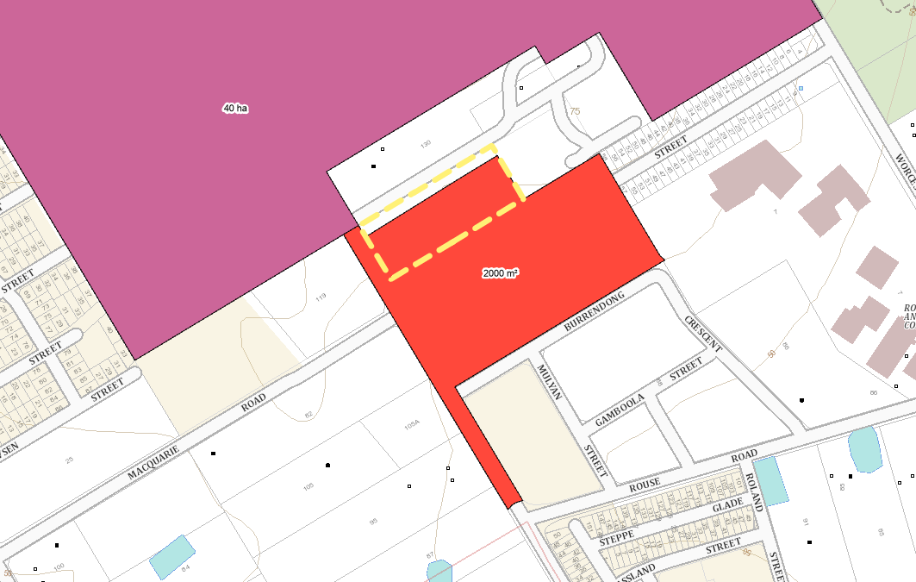

**Figure 4: Current Lot Size Map**

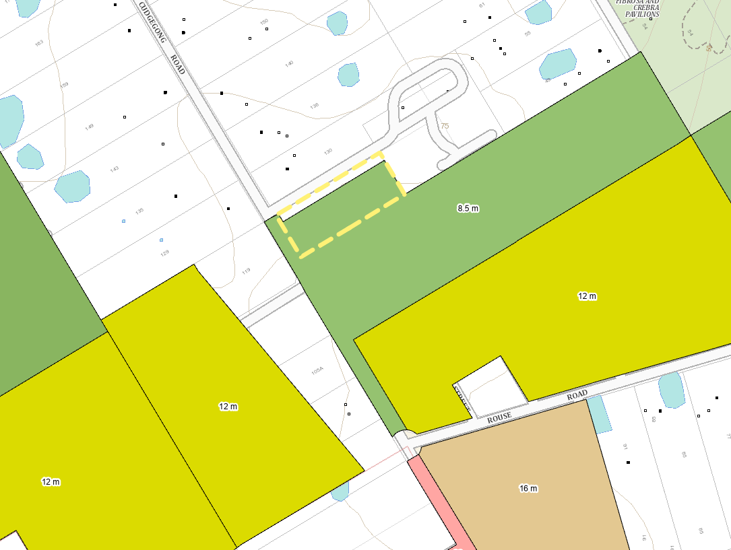

**Figure 5: Current Height of Buildings Map**

**Proposed Amendments**

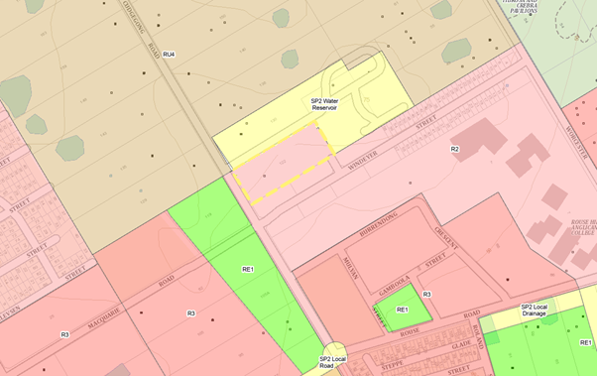

**Figure 6: Proposed Land Zoning Map**

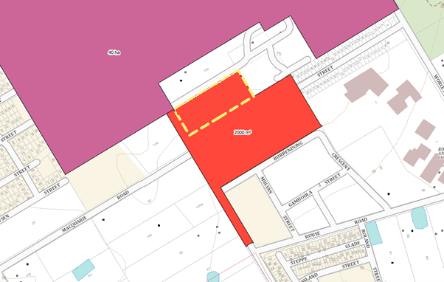

**Figure 7: Proposed Lot Size Map**

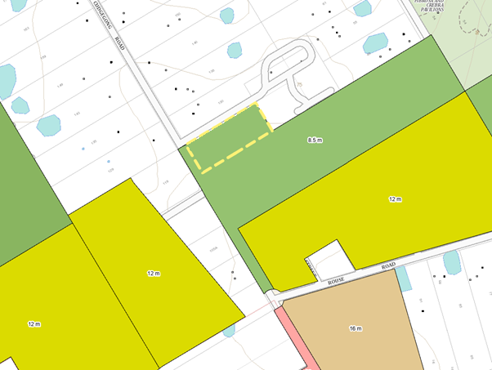

**Figure 8: Proposed Height of Buildings Map**

PART 1 – OBJECTIVES AND INTENDED OUTCOMES

**Objective and Intended Outcomes**

The objective and intended outcome of the Planning Proposal is to:

* remove the SP2 – Water Reservoir zoning that does not reflect the existing (or required) use of the land;
* rezone the subject land R2 – Low Density Residential to reflect the zoning of the remainder of the subject land and surrounding sites; and
* amend the Lot Size Map (to specify a minimum lot size of 2,000m2) and the Height of Buildings Map (to specify a maximum building height of 8.5 metres) to provide consistency with the controls applying to the remainder of the site.

PART 2 – EXPLANATION OF PROVISIONS

The Planning Proposal seeks the following amendments to SEPP (Precincts – Central River City) 2021:

* amend the Land Zoning Map to rezone the subject land from SP2 – Water Reservoir to R2 – Low Density Residential;
* amend the Lot Size Map to specify a minimum lot size of 2,000m2; and
* amend the Height of Buildings Map to specify a maximum building height of 8.5 metres.

PART 3 – JUSTIFICATION OF STRATEGIC AND SITE-SPECIFIC MERIT

**Strategic and Site-Specific Merit**

The proposal is very minor in nature, and is simply intended to remove the current zoning that does not reflect the existing (or required) use of the land, and rezone the land to reflect the zoning of the remainder of the subject land and surrounding sites.

Further, the site is located within the Cudgegong Road (Area 20) Precinct pursuant to the Blacktown City Council (BCC) Growth Centre Precincts Development Control Plan (DCP) 2010. *The Precinct Planning Vision* is expressed as follows:

*The vision for Area 20 Precinct is to create a series of new walkable residential neighbourhoods supported by local retail, employment, community, open space and recreational opportunities. The majority of housing will be in medium density forms, such as semi-detached and townhouses, though the Precinct will provide for a range of densities, dwelling types and affordability options including larger lots and standard detached houses, with apartments in close proximity to Rouse Hill Town Centre and its associated public transport opportunities.*

*The proposed North West Rail Link and new rail station near Cudgegong Road will introduce opportunities for a village centre linked to the station with surrounding higher density residential development and mixed use areas adjacent to the village centre and station. This will offer local residents improved access to jobs and services within the Precinct. Detailed provisions for the Cudgegong Station Area will ensure that the station, commuter car park and rail design is properly integrated with the surrounding land uses.*

*The Precinct is closely associated with the nationally significant Rouse Hill House Estate and the adjacent Rouse Hill Regional Park. New development will incorporate ecological sustainability principles and measures to ensure that the important historic, environmental and visual sensitivities are recognised and protected for future generations.*

*The public domain will respect and interpret the cultural heritage of the Precinct and its relationship to the rural past, as well as conserve significant stands of remnant vegetation, particularly along the Second Ponds Creek Corridor. This will preserve biodiversity and contribute to a strong woodland character.*

The proposal is generally consistent with the *Planning Vision* for the Precinct on the basis that the proposal will remove the current zoning that does not reflect the existing (or required) use of the land, and rezone the land to reflect the zoning of the remainder of the subject land and surrounding sites.

Further, the purpose of the Planning Proposal is to satisfy Conditions 2.1.3 and 5.5.1 of the Development Consent that applies to the land.

Finally, it is proposed to amend the Lot Size Map (to specify a minimum lot size of 2,000m2) and the Height of Buildings Map (to specify a maximum building height of 8.5 metres) to provide consistency with the controls applying to the remainder of the site.

1. NEED FOR THE PLANNING PROPOSAL

**Q1. *Is the planning proposal a result of an endorsed local strategic planning statement (LSPS), strategic study or report?***

The proposal is very minor in nature, and is simply intended to remove the current zoning that does not reflect the existing (or required) use of the land, and rezone the land to reflect the zoning of the remainder of the subject land and surrounding sites.

Further, the purpose of the Planning Proposal is to satisfy Conditions 2.1.3 and 5.5.1 of the Development Consent that applies to the land.

Finally, it is proposed to amend the Lot Size Map (to specify a minimum lot size of 2,000m2) and the Height of Buildings Map (to specify a maximum building height of 8.5 metres) to provide consistency with the controls applying to the remainder of the site.

***Q2. Is the planning proposal the best means of achieving the objectives or intended outcomes, or is there a better way?***

The Planning Proposal is considered the most appropriate means of achieving the objectives and intended outcomes.

1. RELATIONSHIP TO STRATEGIC PLANNING FRAMEWORK

**Q3. *Will the planning proposal give effect to the objectives and actions of the applicable regional, or district plan or strategy (including any exhibited draft plans or strategies)?***

The *Greater Sydney Region Plan, A Metropolis of Three Cities*, is generally intended to set a 40-year vision (to 2056), and establish a 20-year plan to manage growth and change for Greater Sydney in the context of social, economic and environmental matters.

The Plan divides Greater Sydney into five (5) districts, and the subject site is located within the Central City District. The *Central City District Plan* aims to accommodate an additional 53,500 dwellings, including 13,950 dwellings within the Blacktown Local Government Area (LGA). Further, the additional dwellings will be supported by additional infrastructure and employment opportunities.

Again, the proposal is minor in nature, and is simply intended to remove the current zoning that does not reflect the existing (or required) use of the land, and rezone the land to reflect the zoning of the remainder of the subject land and surrounding sites.

**Q4. *Is the planning proposal consistent with a Council LSPS that has been endorsed by the Planning Secretary or GSC, or another endorsed local strategy or strategic plan?***

The *Blacktown Local Strategic Planning Statement 2020* is intended to set out a 20-year vision for the future of Blacktown City as it grows and changes. The 20-year planning vision is expressed as follows:

*A planned city of sustainable growth, supported by essential infrastructure, efficient transport, a prosperous economy and equitable access to a vibrant, healthy lifestyle.*

The subject site is located within the *Riverstone Precinct*, which is generally intended to provide new housing and jobs, capitalising on the Rouse Hill and Riverstone Town Centres, and the significant public transport infrastructure including the Riverstone, Tallawong, Schofields and Quakers Hill Railway Stations.

Again, the proposal is minor in nature, and is simply intended to remove the current zoning that does not reflect the existing (or required) use of the land, and rezone the land to reflect the zoning of the remainder of the subject land and surrounding sites.

**Q5. *Is the planning proposal consistent with any other applicable State and regional studies or strategies?***

The Planning Proposal will not contradict or hinder the application of any applicable State or regional study or strategy.

**Q6. *Is the planning proposal consistent with applicable State Environmental Planning Policies (SEPPs)?***

The purpose of the Planning Proposal is to rezone the subject land from SP2 – Water Reservoir to R2 – Low Density Residential pursuant to (SEPP) (Precincts – Central River City) 2021. The land will continue to be subject to the provisions of the SEPP.

**Q7. *Is the planning proposal consistent with applicable Ministerial Directions (s.9.1 directions)?***

The following table identifies the Section 9.1 Ministerial Directions and outlines the Planning Proposal’s consistency with those Directions.

| **Section 9.1 Directions** | **Consistency of Planning Proposal** |
| --- | --- |
| **Focus Area 1: Planning Systems** | |
| 1.1 Implementation of Regional Plans | The Planning Proposal is consistent with the Greater Sydney Region Plan. |
| 1.2 Development of Aboriginal Land Council Land | Not Applicable |
| 1.3 Approval and Referral Requirements | The Planning Proposal does not introduce any concurrence, consultation or referral requirements. |
| 1.4 Site Specific Provisions | The Planning Proposal allows the permissible uses in the zone to be carried out, adopts an existing zone within the SEPP, and maintains the development standards that apply to the remainder of the site and the surrounding land. |
| **Focus Area 1 – Planning Systems – Place-based** | |
| 1.5 Paramatta Road Corridor Urban Transformation Strategy | Not Applicable |
| 1.6 Implementation of North West Priority Growth Area Land Use and Infrastructure Implantation Plan. | Not Applicable |
| 1.7 Implementation of Greater Parramatta Priority Growth Area Interim Land Use and Infrastructure Implementation Plan | Not Applicable |
| 1.8 Implementation of Wilton Priority Growth Area Interim Land Use and Infrastructure Implementation Plan | Not Applicable |
| 1.9 Implementation of Glenfield to Macarthur Urban Renewal Corridor | Not Applicable |
| 1.10 Implementation of the Western Sydney Aerotropolis Plan | Not Applicable |
| 1.11 Implementation of Bayside West Precincts 2036 Plan | Not Applicable |
| 1.12 Implementation of Planning Principles for the Cooks Cove Precinct | Not Applicable |
| 1.13 Implementation of St Leonards and Crows Nest 2036 Plan | Not Applicable |
| 1.14 Implementation of Greater Macarthur 2040 | Not Applicable |
| 1.15 Implementation of the Pyrmont Peninsula Place Strategy | Not Applicable |
| 1.16 North West Rail Link Corridor Strategy | Not Applicable |
| 1.17 Implementation of the Bays West Place Strategy | Not Applicable |
| 1.18 Implementation of the Macquarie Park Innovation Precinct | Not Applicable |
| 1.19 Implementation of the Westmead Place Strategy | Not Applicable |
| 1.20 Implementation of the Camellia-Rosehill Place Strategy | Not Applicable |
| 1.21 Implementation of the South West Growth Area Structure Plan | Not Applicable |
| 1.22 Implementation of the Cherrybrook Station Place Strategy | Not Applicable |
| **Focus Area 2: Design and Place** | |
| - | - |
| **Focus Area 3: Biodiversity and Conservation** | |
| 3.1 Conservation Zones | Not Applicable |
| 3.2 Heritage Conservation | Not Applicable |
| 3.3 Sydney Drinking Water Catchment | The Planning Proposal will have no impact on the drinking water catchment. |
| 3.4 Application of C2 and C3 Zones and Environmental Overlays in Far North Coast LEPs | Not Applicable |
| 3.5 Recreation Vehicle Areas | Not Applicable |
| 3.6 Strategic Conservation Planning | Not Applicable |
| 3.7 Public Bushland | Not Applicable |
| 3.8 Willandra Lakes Region | Not Applicable |
| 3.9 Sydney Harbour Foreshores and Waterways Area | Not Applicable |
| 3.10 Water Catchment Protection | Not applicable |
| **Focus Area 4: Resilience and Hazards** | |
| 4.1 Flooding | Not Applicable |
| 4.2 Coastal Management | Not Applicable |
| 4.3 Planning for Bushfire Protection | The Planning Proposal will have no impact on planning for bushfire protection. |
| 4.4 Remediation of Contaminated Land | The approved DA (DA-2018-01684) was accompanied by a *Preliminary Site Investigation Report* (*Geotest Services*) which concluded that “*Through implementation of these strategies, contamination at the site should be identified and the risk of human health mitigated”.* |
| 4.5 Acid Sulphate Soils | Not Applicable |
| 4.6 Mine Subsidence and Unstable Land | Not Applicable |
| **Focus Area 5: Transport and Infrastructure** | |
| 5.1 Integrating Land Use and Planning |  |
| 5.2 Reserving Land for Public Purposes | Not Applicable |
| 5.3 Development Near Regulated Airports and Defence Airfields | Not Applicable |
| 5.4 Shooting Ranges | Not Applicable |
| **Focus Area 6: Housing** | |
| 6.1 Residential Zones |  |
| 6.2 Caravan Parks and Manufactured Home Estates | Not Applicable |
| **Focus Area 7: Industry and Employment** | |
| 7.1 Business and Industrial Zones | Not Applicable |
| 7.2 Reduction in Non-hosted and Short-term Rental Accommodation Period | Not Applicable |
| 7.3 Commercial and Retail Development Along the Pacific Highway, North Coast | Not Applicable |
| **Focus Area 8: Resources and Energy** | |
| 8.1 Mining, Petroleum and Extractive Industries | Not Applicable |
| **Focus Area 9: Primary Production** | |
| 9.1 Rural Zones | Not Applicable |
| 9.2 Rural Lands | Not Applicable |
| 9.3 Oyster Aquaculture | Not Applicable |
| 9.4 Farmland of State and Regional Significance on the NSW Far North Coast | Not Applicable |

1. ENVIRONMENTAL, SOCIAL AND ECONOMIC IMPACT

**Q8. *Is there any likelihood that critical habitat or threatened species, populations or ecological communities, or their habitats, will be adversely affected because of the proposal?***

The Planning Proposal will have no impact on any critical habitat or threatened species, populations or ecological communities, or their habitats.

**Q9. *Are there any other likely* *environmental effects of the planning proposal and how are they proposed to be managed?***

The Planning Proposal will have no adverse environmental effects.

***Q10. Has the planning proposal adequately addressed any social and economic effects?***

The Planning Proposal will have no adverse social or economic effects.

1. INFRASTRUCTURE (LOCAL, STATE AND COMMONWEALTH)

**Q11. *Is there adequate public infrastructure for the planning proposal?***

The *Land Use and Infrastructure Implementation Plan* (May 2017) recognises the need to upgrade local infrastructure to service the planned development of the *North West Priority Growth Area*.

In that regard, the Planning Proposal does not generate a need for any additional infrastructure to that which will be provided to service the approved development on the site.

1. STATE AND COMMONWEALTH INTERESTS

**Q12. *What are the views of state and federal public authorities and government agencies consulted in order to inform the Gateway determination?***

On 28 February 2019, the *Sydney Water* Corporation advised the owner that the strip of land zoned SP2 – Water Reservoir was not required for any purpose. Further, the *Sydney Water Corporation* advised the owner that it supported the proposed rezoning, and requested a 2 metre wide easement over the land which is now registered on the title.

PART 4 – MAPPING

The Planning Proposal requires amendment to the following maps:

* the Land Zoning Map to rezone the subject land from SP2 – Water Reservoir to R2 – Low Density Residential;
* the Lot Size Map to specify a minimum lot size of 2,000m2; and
* the Height of Buildings Map to specify a maximum building height of 8.5 metres.

PART 5 – COMMUNITY CONSULTATION

On 28 February 2019, the *Sydney Water* Corporation advised the owner that the strip of land zoned SP2 – Water Reservoir was not required for any purpose. Further, the *Sydney Water Corporation* advised the owner that it supported the proposed rezoning, and requested a 2 metre wide easement over the land which is now registered on the title.

The remaining community consultation will be carried out in accordance with the requirements of the Environmental Planning and Assessment Act 1979.

PART 6 – PROJECT TIMELINE

|  |  |
| --- | --- |
| **Stage** | **Timeframe and/or date** |
| Consideration by Council |  |
| Council decision |  |
| Gateway determination |  |
| Pre-exhibition |  |
| Commencement and completion of public exhibition period |  |
| Consideration of submissions |  |
| Post-exhibition review and additional studies |  |
| Submission to the Department for finalisation (where applicable) |  |
| Gazettal of LEP amendment |  |

**APPENDIX A – LETTER OF APPROVAL – SYDNEY WATER CORPORATION**